Assignment 1
Name : Karthick Sundar C K
Batch : BIT 9
1.Install Power BI Desktop and share the final screenshot of the report view page which appears when power desktop starts.
The power BI desktop is installed with the help of installation PDF shared by the iNeuron team through the dashboard.
Below is the screen shot of the report view page when power BI opens..
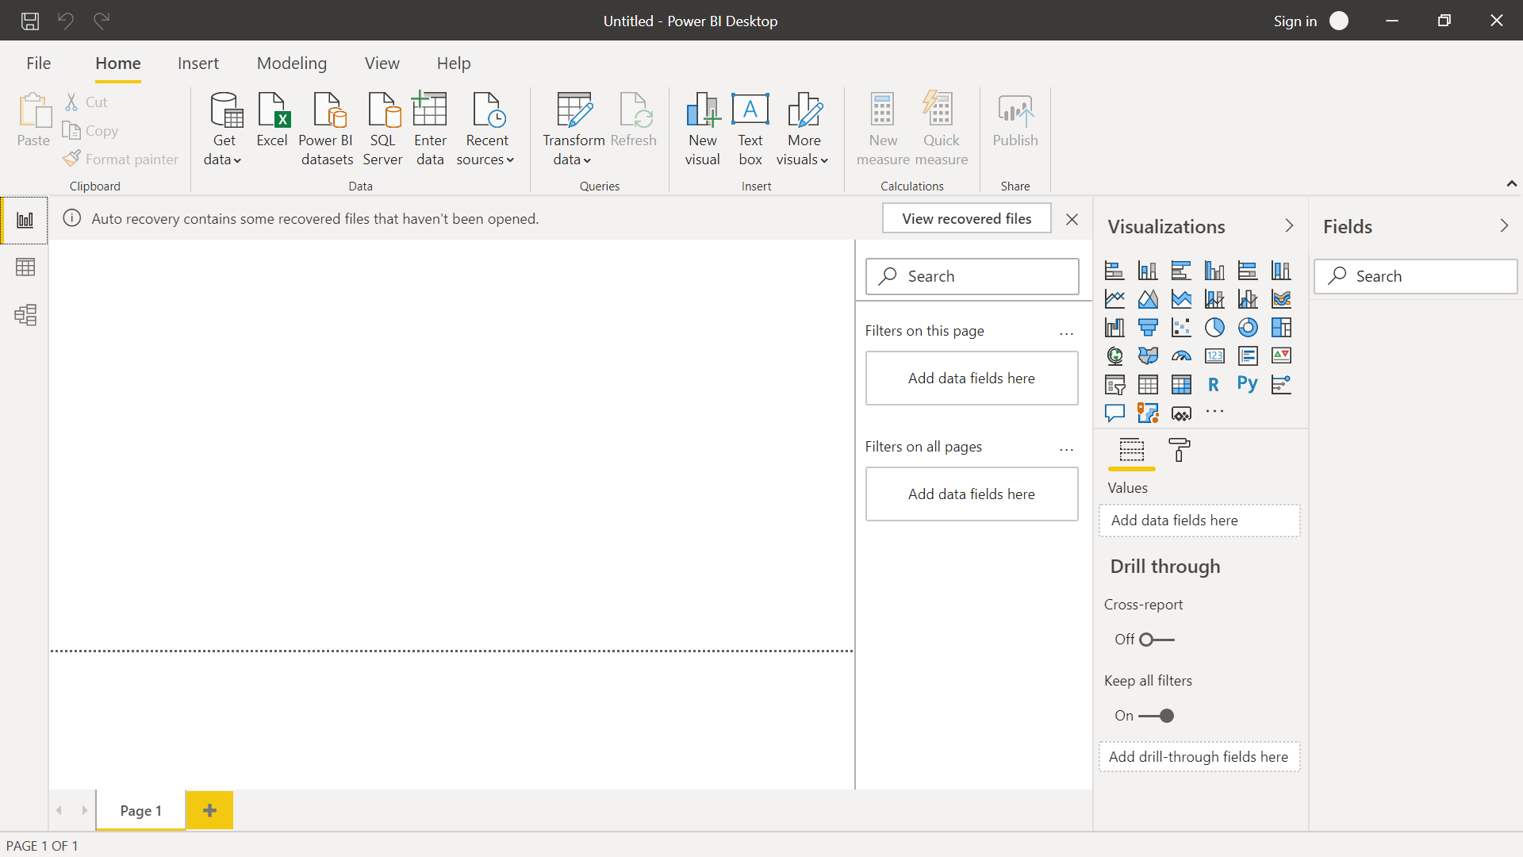

2. Prepare a document and with the following screenshot
Report View:
The report view of Power BI is used to create various visualization based on the data that is brought in to the power BI. The data is first brought in by importing the data from “Get Data” option from the top ribbon. The data may be imported as such or transformed by opening it in using “Power Query Editor”. Below is the screen shot of me using “Store sales data” shared by iNeuron team via the canvas dashboard.
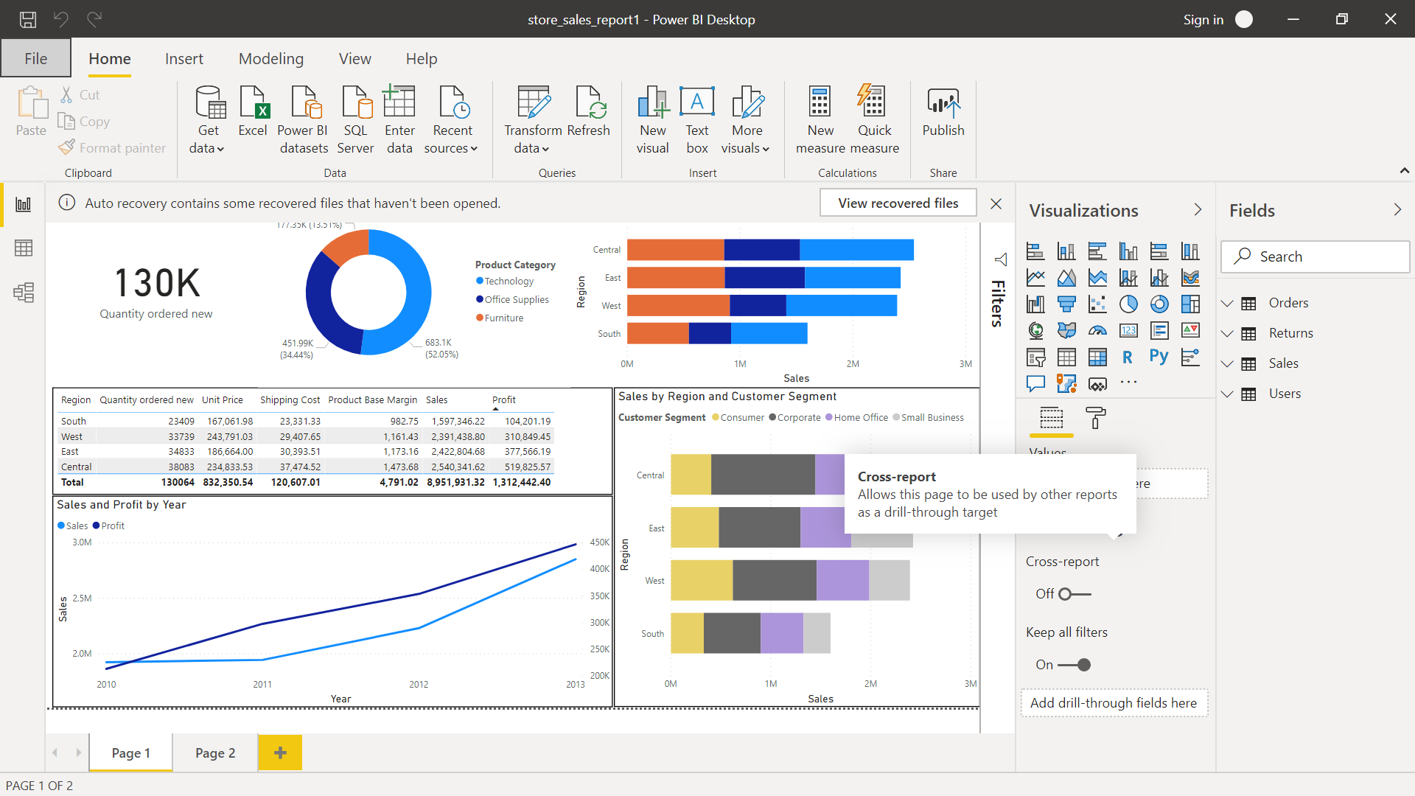
Data View:
This view is basically used to view the content in the table that we have imported into the BI tool. This view will basically help us to play over and see the data in hand. Below is the screen shot of the data view from the “Orders Table”
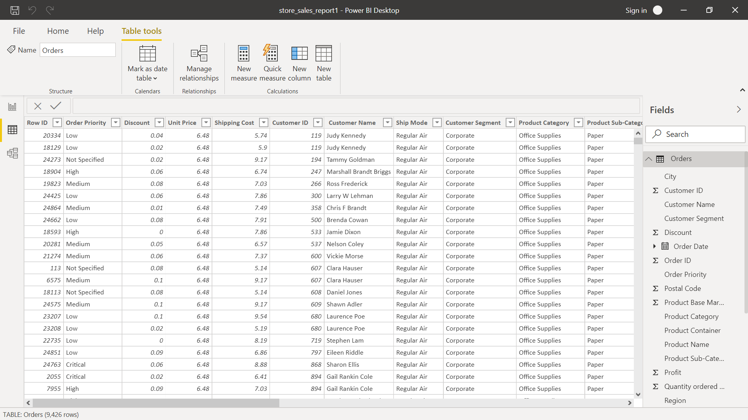

Model View:
Model view is basically builds a relationship if any exists between all the tables that are imported in inside power BI current project. Thus any common key between tables establishes relationship without any manual touch point. Below is the screenshot of the relationship status of multiple tables in “Model View”
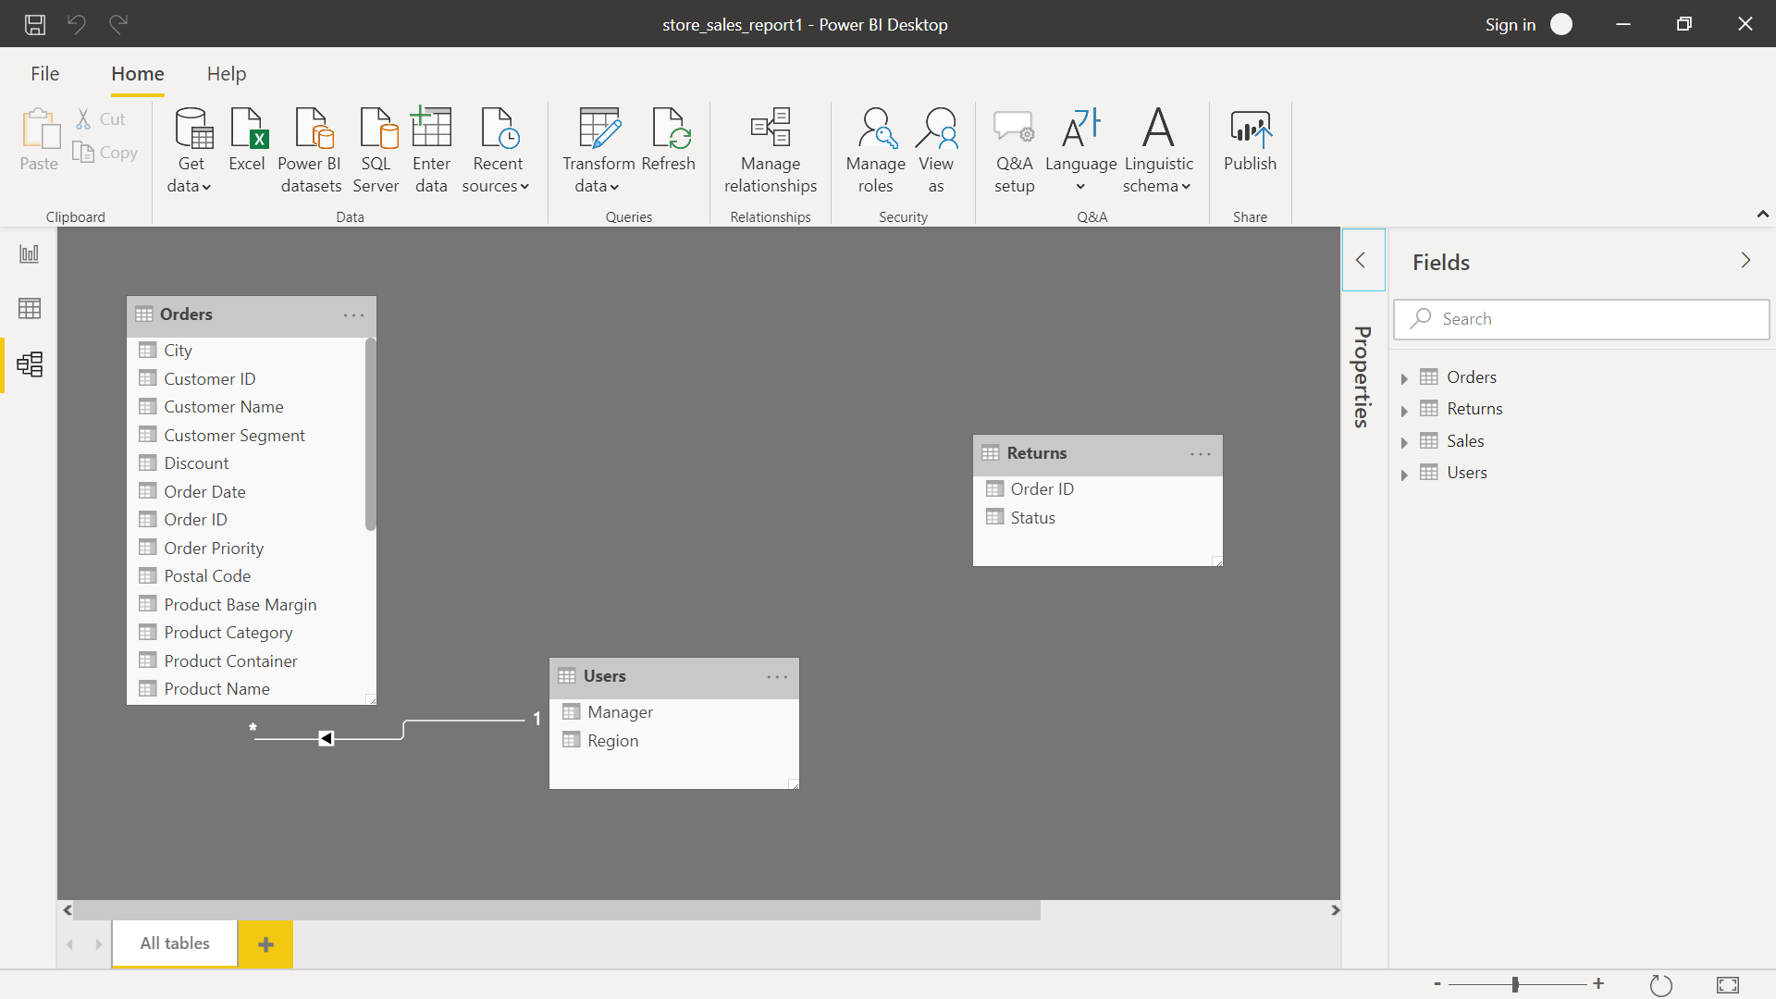

Power Query Editor:
Power query editor is basically a data wrangling tool that helps the user to process/transform the data to any extent before started ahead with our visualization goal. The power query editor has lots of features starting from deleting rows, columns, duplicate rows, duplicate column, transforming top row to header or header to top row, split a column by any regex pattern or group by then like wise. We can also perform transformation at file and folder level by using append and merge queries options available. Below is the screenshot of Power Query editor with some transformation performed.
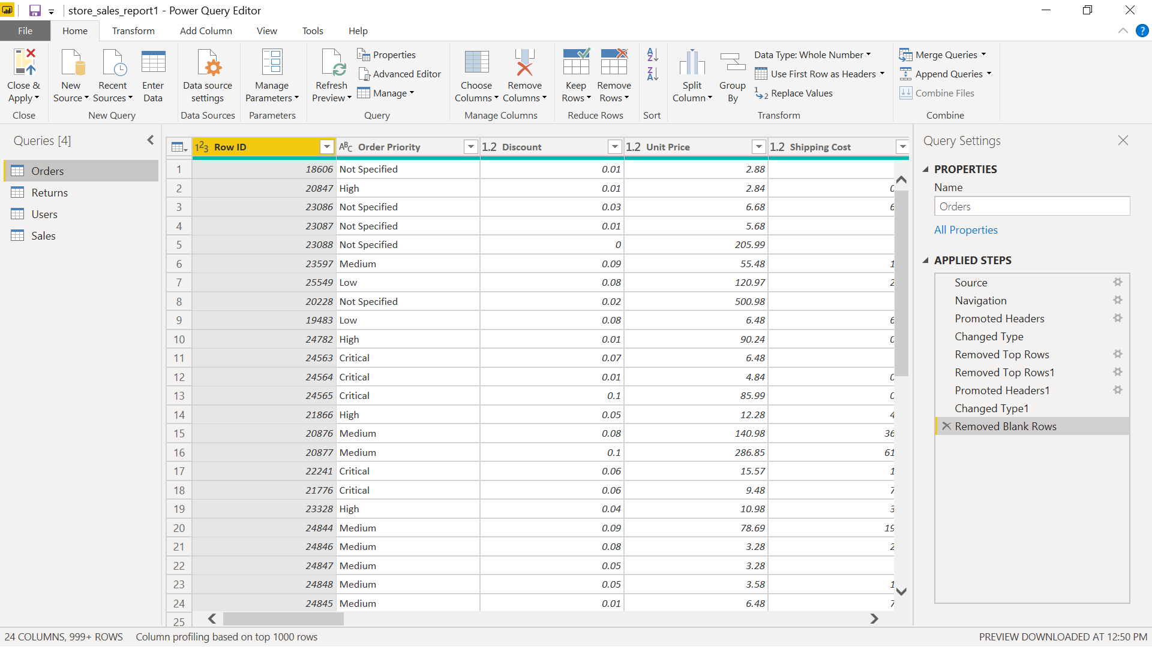

Advanced Editor:
Advanced editor is basically a place where all our actions are recorded with its programmed code format. This is a place where we can see how any of our transformation actions are taking plcae through a backend code. We can also code in using the advanced editor to make any changes/transformations. Below is the screenshot of the advanced editor where all the transformation applied in the power query editor has been recorded in a code format.
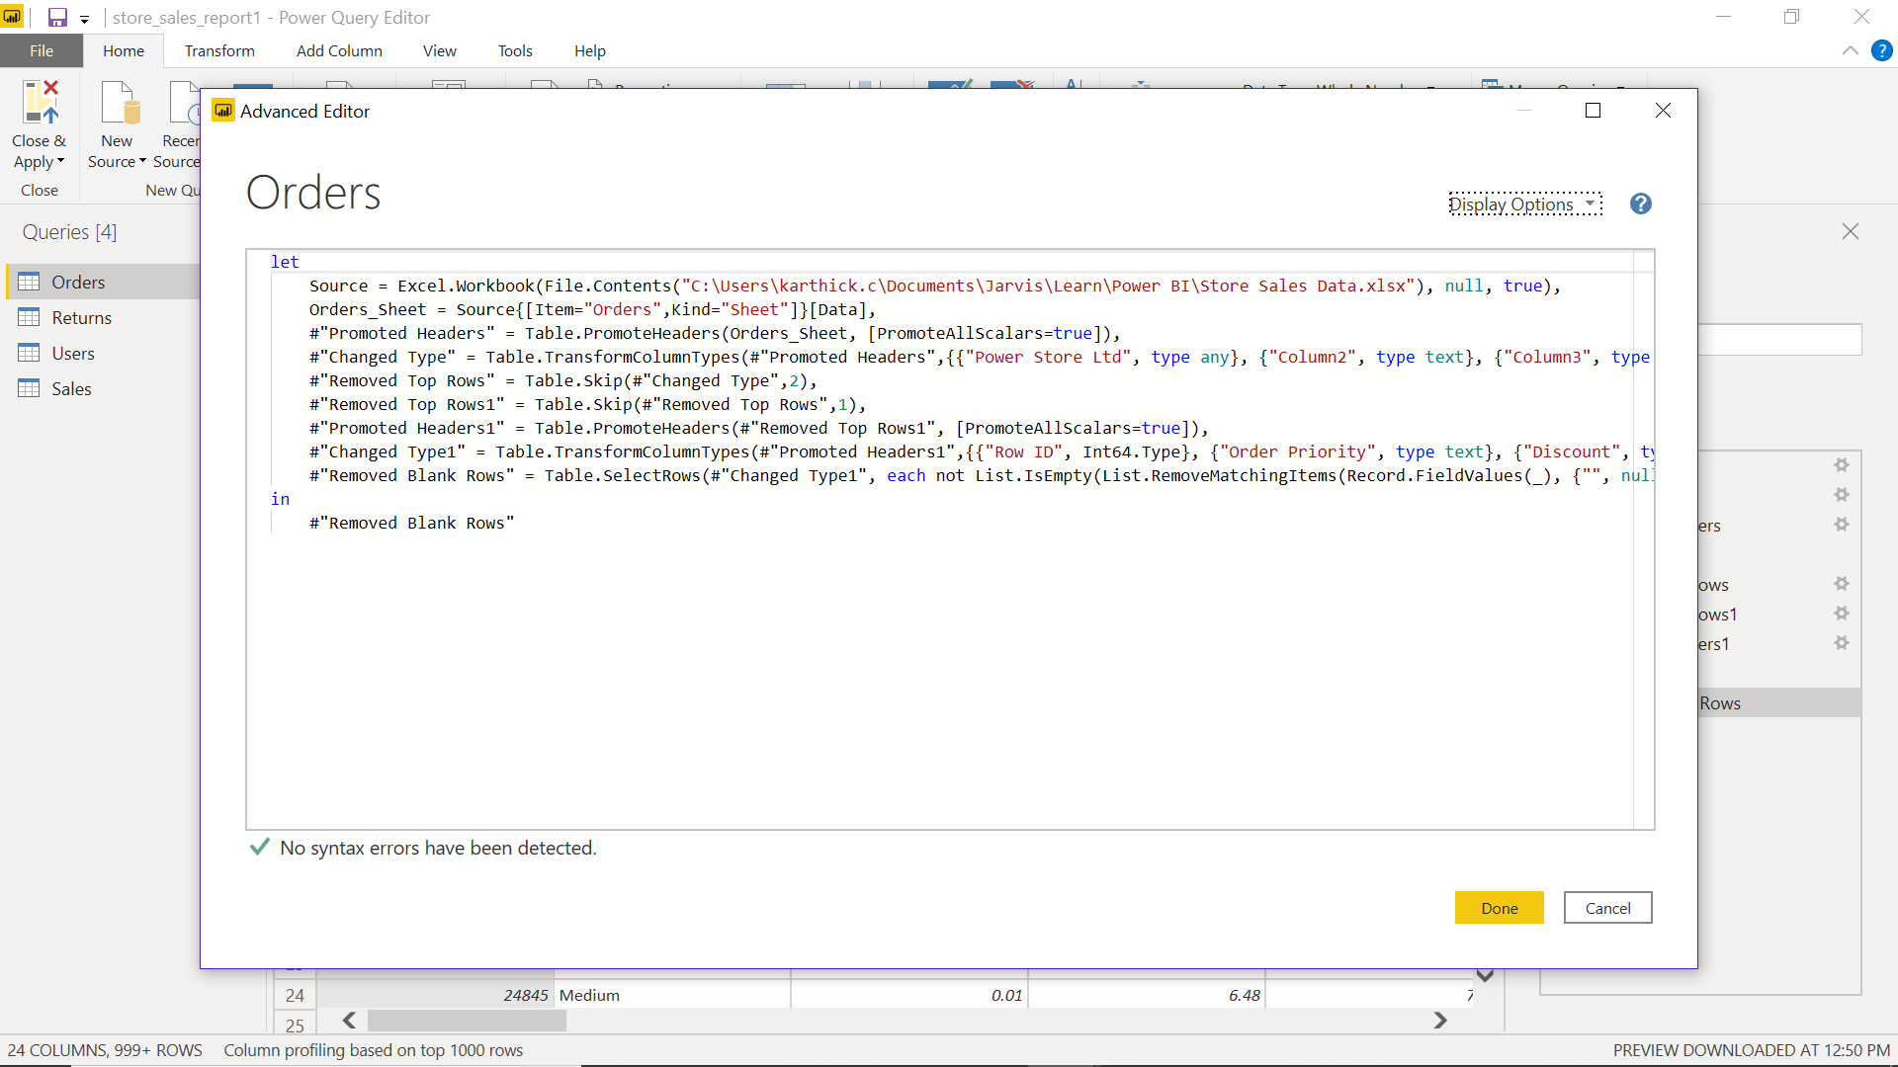
3.Prepare a document with details of the following along with their price:
Power BI desktop:
- Power BI desktop is free and downloadable version that allow us to connect to our data where it is deployed or resides.
- Prepare any data model with ease
- Offers AI driven augmented analytics
- Creative and interactive reports can be developed
- One cannot publish any report unless until they have an organizational version of power BI desktop or move to power BI pro or premium
Power BI Pro:
- We can get Power BI Pro for $9.99/month
- Power BI is the modern BI hosted on cloud
- Collaboration, publishing, sharing and any ad-hoc analysis is made easy
- Fully managed by Microsoft
- Compute and process for Pro version happens on a shared environment on cloud
- Maximum size of individual dataset can me 1 gb
- Maximum storage is 10 GB
- Maximum number of auto-refresh per day is 8
Power BI premium:
- We can upgrade from Pro version to premium with $4995/month
- This is an enterprise version of BI, BigData analytics with cloud on-premise set up
- Advanced administration and deployment controls are available
- Dedicated cloud compute and storage options
- Allows any user to consume BI content
- Maximum size of individual dataset can be 10GB
- Maximum storage is 100TB
- Maximum number of auto-refreshes every day is 48

